Project Design Phase-II
Data Flow Diagram & User Stories

Date | 17 February 2026
Team ID | LTVIP2026TMIDS39366
Project Name | Heritage Treasures: An In-Depth Analysis of UNESCO World Heritage Sites (2019)
Maximum Marks | 8 Marks

Data Flow Diagrams:
The Level 0 Data Flow Diagram represents the overall structure of the Heritage Treasures: An In-Depth Analysis of UNESCO World Heritage Sites (2019) system. It provides a high-level view of how data flows within the system. In this diagram, the Researcher or User interacts with the Heritage Analytics System by applying search filters such as country, category, and year. The system retrieves raw data from the UNESCO World Heritage Dataset (2019) and processes it using Tableau. After processing, the system generates interactive dashboards that display comparative analysis and trend-based insights. Level 0 mainly focuses on showing how data enters the system, how it is processed at a general level, and how the final output is delivered to the user.
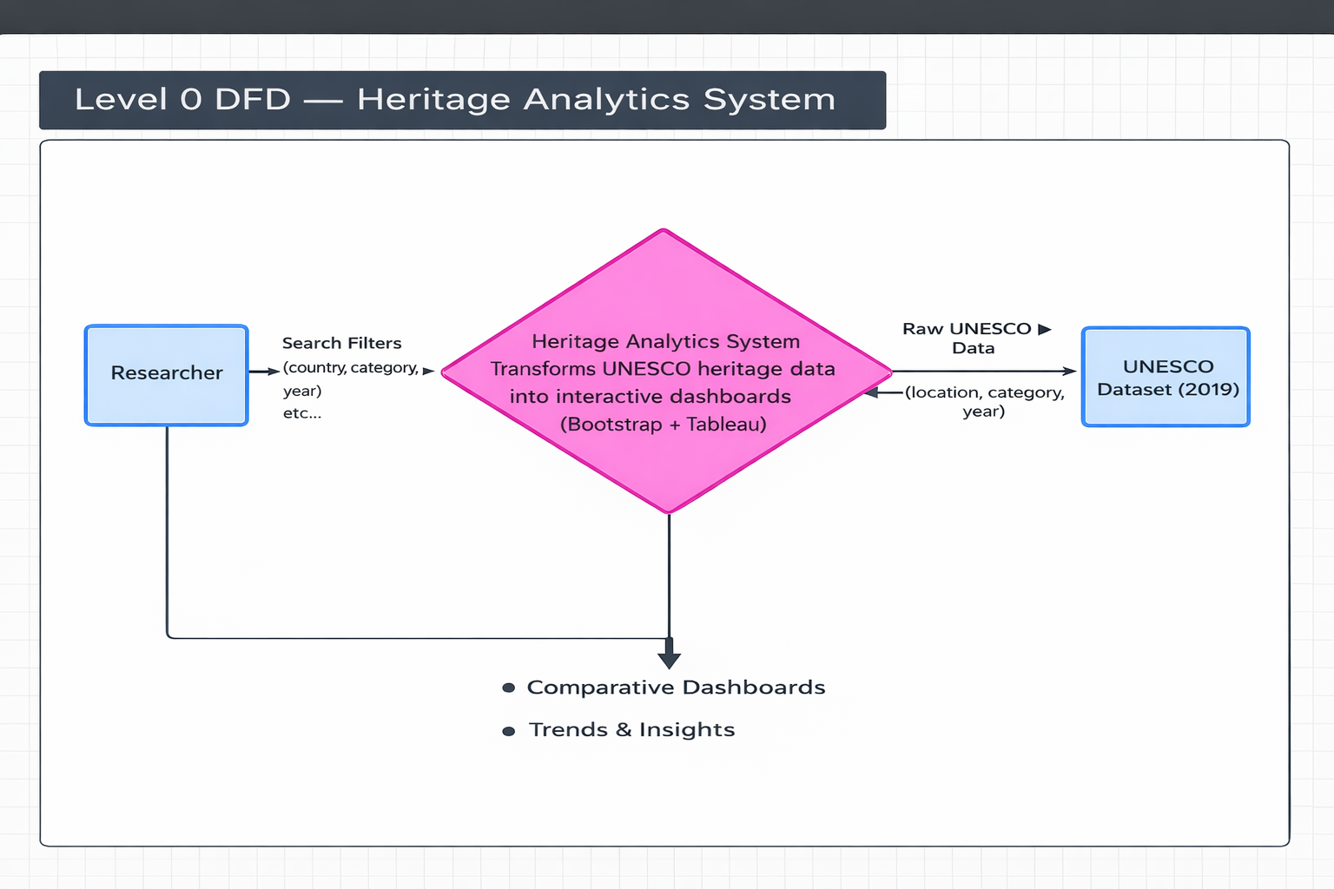
Level 1 Data Flow Diagram:
The Level 1 Data Flow Diagram provides a more detailed representation of the internal working of the Heritage Analytics System. It breaks down the main system into smaller processes such as search filtering, data analysis, dashboard generation, and publishing. In this level, the Researcher submits filters to refine the UNESCO dataset, and the system performs data filtering and analytical operations. The Administrator manages and uploads the UNESCO dataset to Tableau for processing. The processed data is then published to Tableau Public, where interactive dashboards and trend visualizations are generated. These dashboards are accessed by users through the website interface. Level 1 explains the internal modules, data storage, and step-by-step processing that occurs within the system.

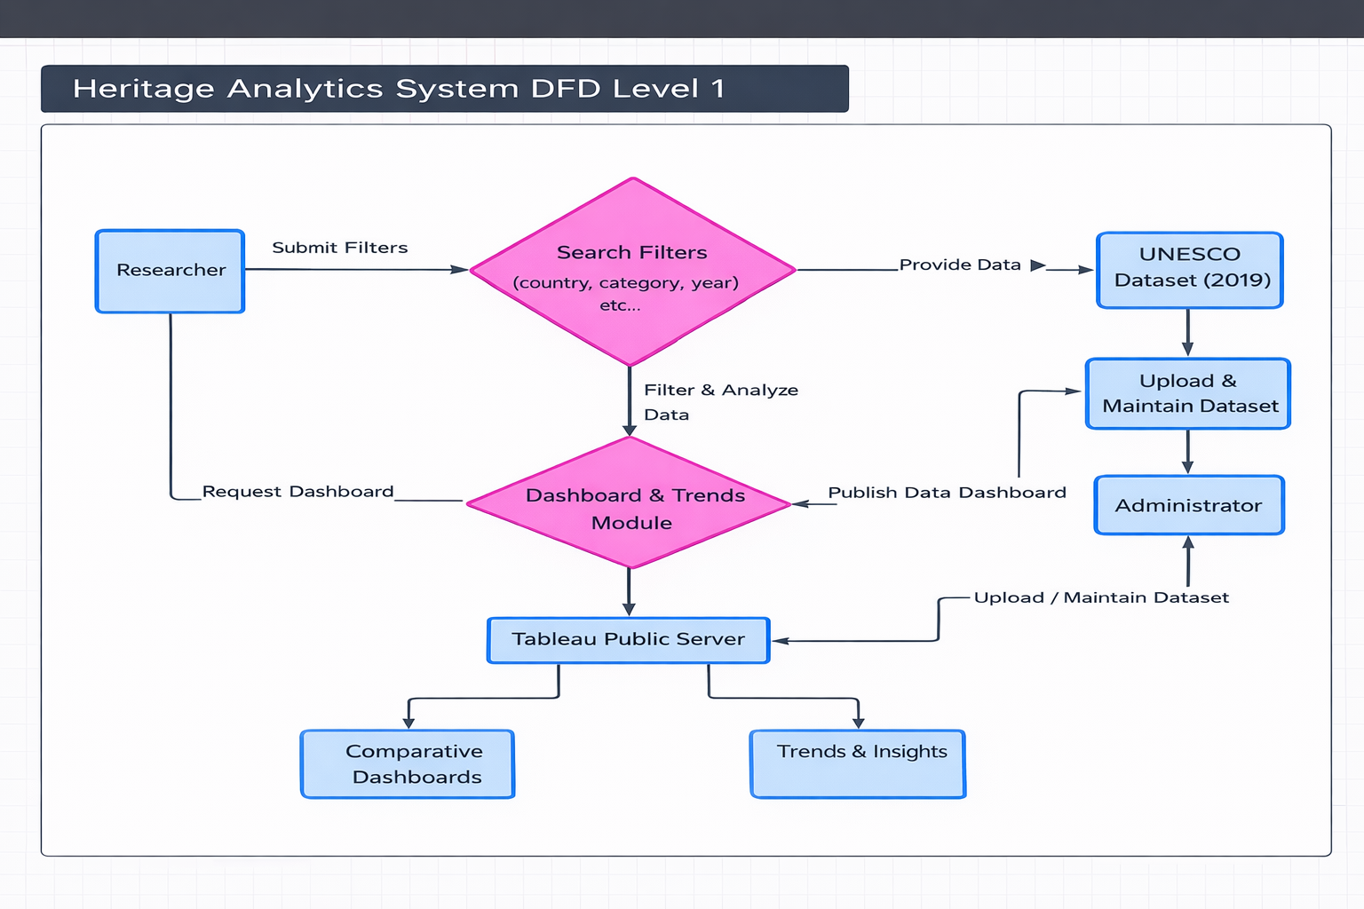
User Stories
Use the below template to list all the user stories for the product.
User Type | Functional Requirement | USN | User Story | Acceptance Criteria | Priority | Release
Researcher (Web user) | Website Access | USN-1 | As a user, I can access the Heritage Treasures website from any browser. | Website loads successfully | High | Sprint-1
Researcher | View Dashboard | USN-2 | As a user, I can view the UNESCO Global Overview Dashboard. | Dashboard loads correctly | High | Sprint-1
Researcher | View Story | USN-3 | As a user, I can explore the Heritage Analytics Story. | Story navigation works | High | Sprint-1
Researcher | Navigation | USN-4 | As a user, I can navigate between Home, About, Dashboard, Story, Team & Contact sections. | Navigation works smoothly | High | Sprint-1
Researcher | Contact Form | USN-5 | As a user, I can submit feedback through the contact form. | Form validation works | High | Sprint-1
Researcher | Responsive Design | USN-6 | As a user, I can access the website on mobile and desktop. | Layout responsive | Medium | Sprint-2
Administrator | Data Upload | USN-7 | As an admin, I can upload UNESCO dataset to Tableau. | Dataset uploads successfully | High | Sprint-1
Administrator | Dashboard Update | USN-8 | As an admin, I can update dashboard visuals. | Updates reflected instantly | High | Sprint-1
Administrator | Publish Dashboard | USN-9 | As an admin, I can publish dashboard to Tableau Public. | Dashboard embed works | High | Sprint-1

